Spring boot Interceptor
- It is a powerful tool used to intercept HTTP requests and responses.
- It allows you to perform operations before or after a request reaches the controller or after the response is sent back to the client.
- Interceptors are commonly used for tasks like logging, authentication, authorization, or modifying requests and responses.
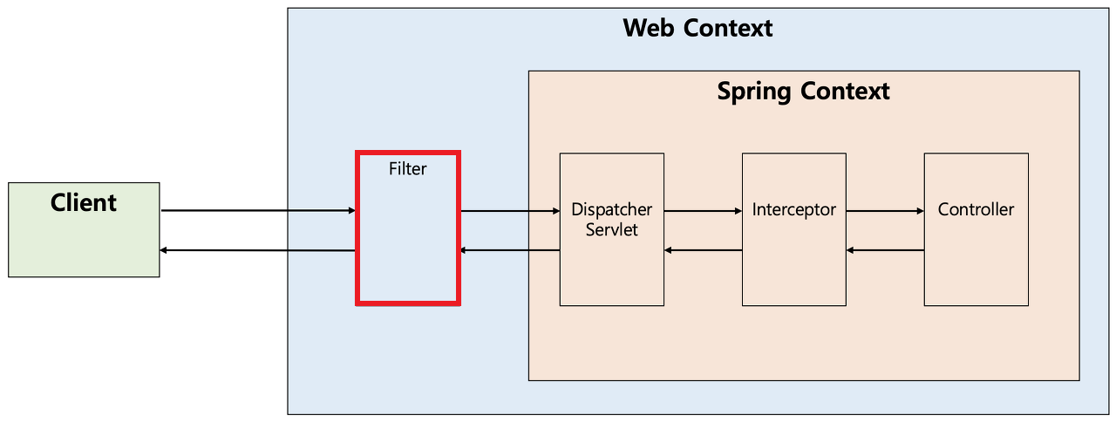
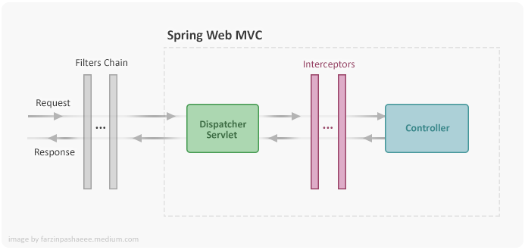

To implement Interceptor, we need 2 interfaces
For Creating Interceptor
- HandlerInterceptor – it has three methods like preHandle(), postHandle() and afterComplition()
public boolean preHandle(HttpServletRequest request, HttpServletResponse response, Object handler) ;
public void postHandle(HttpServletRequest request, HttpServletResponse response, Object handler, ModelAndView modelAndView) ;
public void afterCompletion(HttpServletRequest request, HttpServletResponse response, Object handler, Exception ex);

For Registering the created Interceptors
- WebMvcConfigurer – it has only one method addInterceptors(InterceptorRegistry registry)
public void addInterceptors(InterceptorRegistry registry);

Example Implementation
Step 1: Create the Interceptor
@Component
public class MyInterceptor implements HandlerInterceptor {

@Override
public boolean preHandle(HttpServletRequest request, HttpServletResponse response, Object handler) throws Exception {
System.out.println("Pre Handle method is called");
return true; // Return false to block the request
}

@Override
public void postHandle(HttpServletRequest request, HttpServletResponse response, Object handler, ModelAndView modelAndView) throws Exception {
System.out.println("Post Handle method is called");
}

@Override
public void afterCompletion(HttpServletRequest request, HttpServletResponse response, Object handler, Exception ex) throws Exception {
System.out.println("After Completion method is called");
}
}

Step 2: Register the Interceptor
@Configuration
public class WebConfig implements WebMvcConfigurer {

@Autowired
private MyInterceptor myInterceptor;

@Override
public void addInterceptors(InterceptorRegistry registry) {
registry.addInterceptor(myInterceptor);
}
}

Use Case | Description | Example
Logging and Auditing | Track details of incoming requests and outgoing responses. | Log timestamps, endpoints, payloads, and HTTP statuses.
Authentication | Validate user credentials or tokens to ensure secure access. | Block unauthorized users or invalid API keys.
Input Validation | Ensure that request parameters or payloads meet the expected requirements. | Validate mandatory fields in a JSON body.
Rate Limiting | Limit the number of API calls a client can make in a certain time frame. | Prevent API abuse or DoS attacks.
Custom Header Injection | Add or modify HTTP headers dynamically during request/response processing. | Add X-Frame-Options or a unique tracking ID header.
Localization | Detect and set user-preferred languages based on headers or query parameters. | Serve responses in en, fr, etc., based on locale.
Performance Monitoring | Measure time taken by each endpoint to process requests. | Identify slow endpoints by logging response times.
Caching | Serve cached responses for specific requests instead of reprocessing. | Return cached results for repeated search queries.
Session Management | Track or enforce session-based rules, like timeouts. | Reject requests if the session has expired.
CSRF Protection | Validate anti-CSRF tokens included in the request. | Prevent unauthorized cross-site requests.
Error Handling | Modify error messages or standardize HTTP response codes. | Convert exceptions into custom error JSON payloads.

Filters

Filters are part of the Servlet API and can be used for cross-cutting concerns like security, logging, or request transformation.

Create and register the filters
Step 1: Implement the Filter Interface
import javax.servlet.Filter;
import javax.servlet.FilterChain;
import javax.servlet.ServletRequest;
import javax.servlet.ServletResponse;
import javax.servlet.http.HttpServletRequest;
import org.springframework.stereotype.Component;

@Component
public class RequestLoggingFilter implements Filter {

@Override
public void doFilter(ServletRequest request, ServletResponse response, FilterChain chain) throws java.io.IOException, javax.servlet.ServletException {
HttpServletRequest httpRequest = (HttpServletRequest) request;
System.out.println("Incoming Request: " + httpRequest.getMethod() + " " + httpRequest.getRequestURI());

// Proceed to the next filter or target resource
chain.doFilter(request, response);

// You can also add post-processing logic here if needed
System.out.println("Response sent back to client.");
}
}

Step 2: Customize Filter Registration (Optional)

Spring Boot automatically detects filters annotated with @Component or registered explicitly in configuration classes.

Using FilterRegistrationBean: If you want more control, you can use the FilterRegistrationBean to configure the filter.

import org.springframework.boot.web.servlet.FilterRegistrationBean;
import org.springframework.context.annotation.Bean;
import org.springframework.context.annotation.Configuration;

@Configuration
public class FilterConfig {

@Bean
public FilterRegistrationBean<RequestLoggingFilter> loggingFilter() {
FilterRegistrationBean<RequestLoggingFilter> registrationBean = new FilterRegistrationBean<>();
registrationBean.setFilter(new RequestLoggingFilter());
registrationBean.addUrlPatterns("/api/*"); // Apply filter only to /api endpoints
registrationBean.setOrder(1); // Set execution order if multiple filters exist
return registrationBean;
}
}

